2.VISUALIZATION OF TIME SERIES DATA 221501118

AIM:

To implement visualization techniques on the google trends time series dataset.

PROCEDURE:

**Load the dataset** – Read the Google Trends dataset using Pandas.

**Display initial records** – Use .head() to preview the first few rows.

**Visualize trends by region** – Create a count plot of trend searches by location using Seaborn.

**Generate a heatmap** – Pivot the data and plot a heatmap to show trends across regions over the years.

**Analyze trends over years** – Group the data by year and count the number of trending queries.

**Plot trends over time** – Create a line chart showing the number of trending queries per year.

**Plot a bar chart** – Visualize the average rank over the years using a bar plot.

**Plot a box plot** – Show the distribution of ranks over different years using a box plot.

CODE:

import pandas as pd

import matplotlib.pyplot as plt

import seaborn as sns

df = pd.read_csv('/content/trends.csv')

plt.figure(figsize=(12, 20))

sns.countplot(y=df['location'], order=df['location'].value_counts().index, palette='viridis')

plt.title("Number of trend searches by each region")

plt.xlabel("Count")

plt.ylabel("Region")

plt.show()

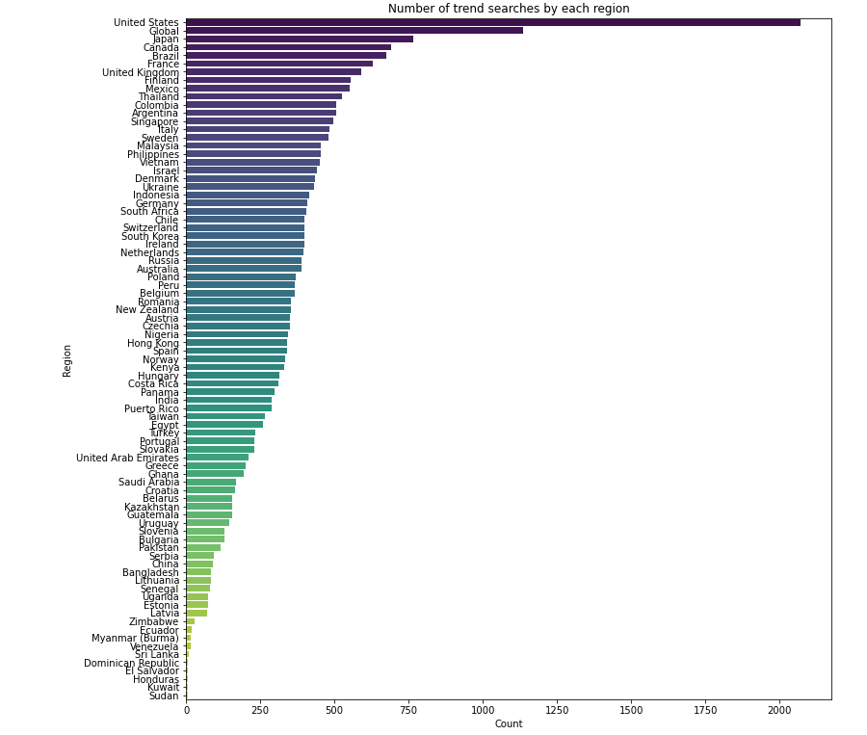

plt.figure(figsize=(12, 20))

heatmap_data = df.pivot_table(index='location', columns='year', values='rank', aggfunc='count')

sns.heatmap(heatmap_data, cmap='coolwarm', annot=True, fmt=".0f", linewidths=0.5)

plt.title("Trends over each region by year")

plt.xlabel("Year")

plt.ylabel("Region")

plt.show()

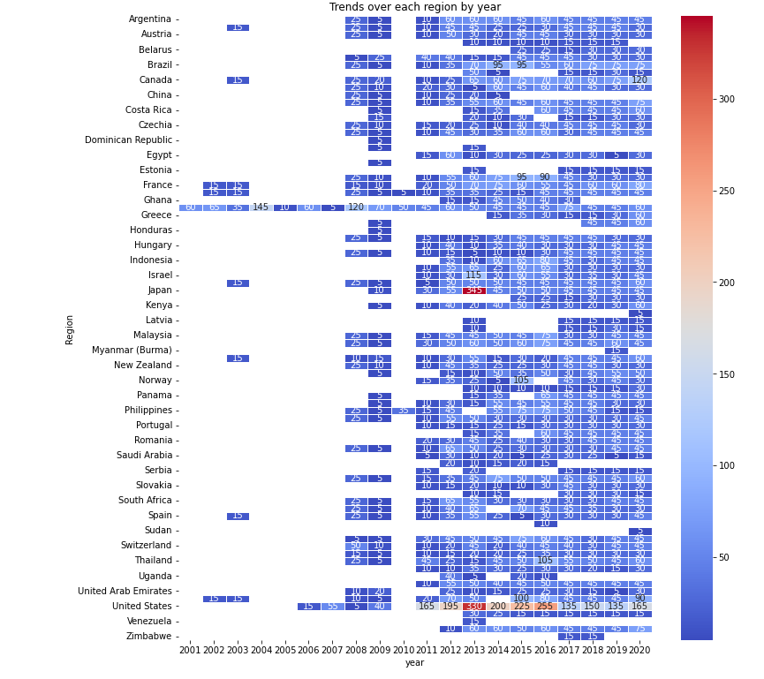

trends_per_year = df.groupby('year')['query'].count()

plt.figure(figsize=(12, 6))

trends_per_year.plot(kind='line', marker='o', color='b', linestyle='-')

plt.xlabel('Year')

plt.ylabel('Number of Trending Queries')

plt.title('Google Trends Over the Years')

plt.grid()

plt.show()

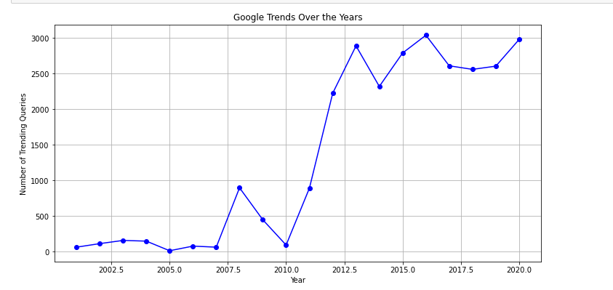

plt.figure(figsize=(12, 6))

sns.barplot(x='year', y='rank', data=df, ci=None)

plt.xlabel("Year")

plt.ylabel("Average Rank")

plt.title("Average Google Trends Rank Over Years")

plt.xticks(rotation=45)

plt.show()

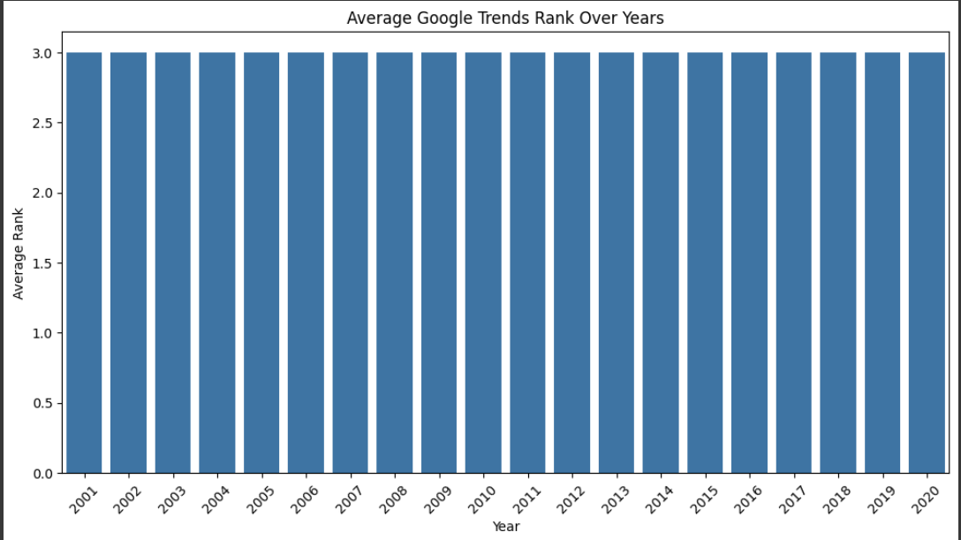

plt.figure(figsize=(12, 6))

sns.boxplot(x='year', y='rank', data=df)

plt.xlabel("Year")

plt.ylabel("Rank Distribution")

plt.title("Google Trends Rank Distribution Over Years")

plt.xticks(rotation=45)

plt.show()

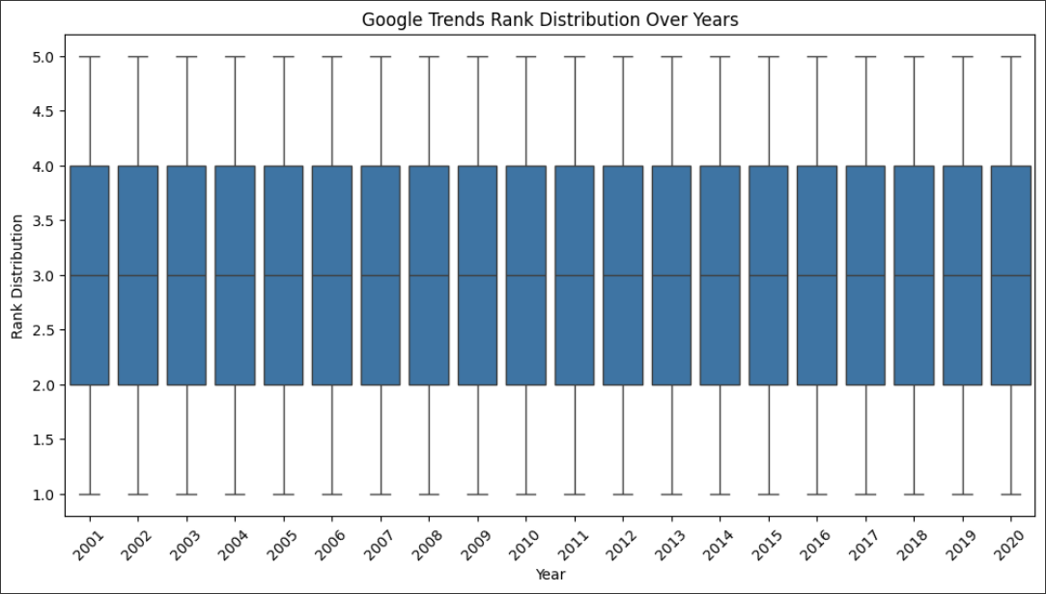

RESULT:

Hence the implementation of visualization in time series dataset is implemented successfully